Single Crystal X-Ray Diffraction Service

National Crystallography Service

Contact: Dr S.K.Callear, S.K.Callear@soton.ac.uk
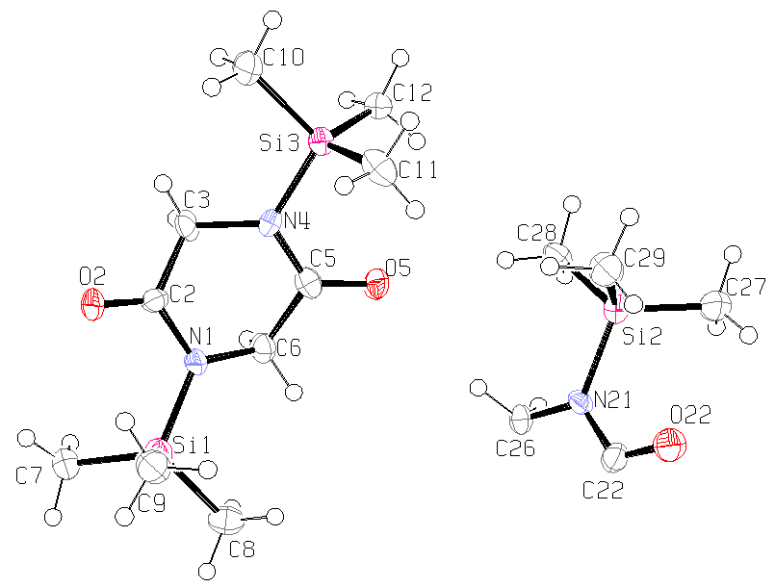
Table 1. Crystal data and structure refinement details.

Identification code 2008src1017 (SM 51L)
Empirical formula C₁₀H₂₂N₂O₂Si₂
Formula weight 258.48
Temperature 120(2) K
Wavelength 0.71073 Å
Crystal system Triclinic
Space group P−1
Unit cell dimensions a = 10.6069(12) Å α = 83.058(7)°
b = 10.7107(13) Å β = 64.192(6)°
c = 10.7782(15) Å γ = 88.751(9)°
Volume 1093.6(2) Å³
Z 3
Density (calculated) 1.177 Mg / m³
Absorption coefficient 0.234 mm⁻¹
F(000) 420
Crystal fragment; colourless
Crystal size 0.14 × 0.08 × 0.02 mm³
θ range for data collection 2.92 − 27.48°
Index ranges −13 ≤ h ≤ 13, −13 ≤ k ≤ 13, −13 ≤ l ≤ 13
Reflections collected 15672
Independent reflections 4889 [R_{int} = 0.1521]
Completeness to θ = 27.48° 97.6 %
Absorption correction Semi−empirical from equivalents
Max. and min. transmission 0.9953 and 0.9680
Refinement method Full-matrix least-squares on F²
Data / restraints / parameters 4889 / 0 / 226
Goodness-of-fit on F² 1.176
Final R indices [F² > 2σ(F²)] R1 = 0.1451, wR2 = 0.2243
R indices (all data) R1 = 0.2538, wR2 = 0.2719
Largest diff. peak and hole 0.562 and −0.493 e Å⁻³

Diffractometer: Nonius KappaCCD area detector (φ scans and ω scans to fill asymmetric unit). Cell determination: DirAx (Duisenberg, A.J.M.(1992). J. Appl. Cryst. 25, 92-96.) Data collection: Collect (Collect: Data collection software, R. Hooft, Nonius B.V., 1998). Data reduction and cell refinement: Denzo (Z. Otwinowski & W. Minor, Methods in Enzymology (1997) Vol. 276: Macromolecular Crystallography, part A, pp. 307−326; C. W. Carter, Jr. & R. M. Sweet, Eds., Academic Press). Absorption correction: Sheldrick, G. M. SADABS - Bruker Nonius area detector scaling and absorption correction - V2.10 Structure solution: SHELXS97 (G. M. Sheldrick, Acta Cryst. (1990) A46 467−473). Structure refinement: SHELXL97 (G. M. Sheldrick (1997), University of Göttingen, Germany). Graphics: ORTEP-3 (L.G. Farrugia, J. Appl. Cryst. (1997) 30, 565).

Special details:
The poor data is due to poor crystal quality, however all hydrogens were located on the difference map before being fixed using a standard riding model.
Table 2. Atomic coordinates [× 10⁴], equivalent isotropic displacement parameters [Å² × 10³] and site occupancy factors. U_{eq} is defined as one third of the trace of the orthogonalized U^{ij} tensor.

Atom x y z U_{eq} S.o.f.

Si1 1623(2) 3279(2) 3377(2) 27(1) 1
Si2 1592(2) 7702(2) 9444(2) 28(1) 1
Si3 4588(2) 8287(2) 3186(2) 26(1) 1
O5 3528(6) 6215(5) 5466(5) 32(1) 1
O22 −1336(6) 7024(5) 11118(6) 35(1) 1
O2 3243(6) 5109(5) 1001(5) 32(1) 1
N21 708(7) 6214(6) 9737(6) 23(1) 1
N1 2932(7) 4407(6) 3193(6) 26(2) 1
C2 3561(7) 5166(7) 1962(7) 23(2) 1
N4 4287(7) 6661(6) 3139(6) 27(2) 1
C6 3479(8) 4520(7) 4221(8) 28(2) 1
C5 3762(8) 5870(7) 4338(8) 26(2) 1
C22 −676(8) 6118(8) 10587(8) 28(2) 1
C26 1484(8) 5112(7) 9139(8) 27(2) 1
C3 4693(8) 6086(8) 1826(8) 28(2) 1
C12 5871(8) 8484(7) 3886(8) 30(2) 1
C28 3456(9) 7451(8) 8259(8) 35(2) 1
C8 1062(8) 2373(8) 5134(8) 34(2) 1
C27 1475(9) 8154(8) 11102(8) 38(2) 1
C11 2869(9) 8951(8) 4209(9) 40(2) 1
C29 844(10) 8922(8) 8586(9) 39(2) 1
C7 2389(9) 2196(8) 2020(8) 35(2) 1
C10 5335(11) 9028(9) 1356(8) 48(3) 1
C9 121(8) 4147(8) 3285(9) 38(2) 1
Table 3. Bond lengths [Å] and angles [°].

Si1−N1 1.790(6)
Si1−C9 1.860(9)
Si1−C8 1.865(8)
Si1−C7 1.866(8)
Si2−N21 1.790(6)
Si2−C27 1.859(8)
Si2−C28 1.863(9)
Si2−C29 1.870(8)
Si3−N4 1.787(7)
Si3−C12 1.847(8)
Si3−C11 1.852(9)
Si3−C10 1.854(8)
O5−C5 1.232(8)
O22−C22 1.230(9)
O2−C2 1.229(8)
N21−C22 1.348(9)
N21−C26 1.472(10)
N1−C2 1.363(9)
N1−C6 1.474(9)
C2−C3 1.516(10)
N4−C5 1.352(9)
N4−C3 1.496(9)
C6−C5 1.515(11)
C6−H6A 0.9900
C6−H6B 0.9900
C22−C26^{i} 1.515(11)
C26−C22^{i} 1.515(11)
C26−H26A 0.9900
C26−H26B 0.9900
C3−H3A 0.9900
C3−H3B 0.9900
C12−H12A 0.9800
C12−H12B 0.9800
C12−H12C 0.9800
C28−H28A 0.9800
C28−H28B 0.9800
C28−H28C 0.9800
C8−H8A 0.9800
C8−H8B 0.9800
C8−H8C 0.9800
C27−H27A 0.9800
C27−H27B 0.9800
C27−H27C 0.9800
C11−H11A 0.9800
C11−H11B 0.9800
C11−H11C 0.9800
C29−H29A 0.9800
C29−H29B 0.9800
C29−H29C 0.9800
C7−H7A 0.9800
C7−H7B 0.9800
C7−H7C 0.9800
C10−H10A 0.9800
C10−H10B 0.9800
C10−H10C 0.9800
C9−H9A 0.9800
C9−H9B 0.9800
C9−H9C 0.9800

N1−Si1−C9 108.2(4)
N1−Si1−C8 106.1(3)
C9−Si1−C8 110.0(4)
N1−Si1−C7 109.9(3)
C9−Si1−C7 112.8(4)
C8−Si1−C7 109.7(4)
N21−Si2−C27 110.5(3)
N21−Si2−C28 105.0(3)
C27−Si2−C28 109.6(4)
N21−Si2−C29 109.8(3)
C27−Si2−C29 111.4(4)
C28−Si2−C29 110.2(4)
N4−Si3−C12 111.1(3)
N4−Si3−C11 107.5(4)
C12−Si3−C11 113.1(4)
N4−Si3−C10 105.8(4)
C12−Si3−C10 108.7(4)
C11−Si3−C10 110.3(4)
C22−N21−C26 121.1(6)
C22−N21−Si2 117.8(5)
C26−N21−Si2 121.0(5)
C2−N1−C6 116.5(6)
C2−N1−Si1 117.9(5)
C6−N1−Si1 125.4(5)
O2−C2−N1 122.3(7)
O2−C2−C3 121.2(6)
N1−C2−C3 116.5(6)
C5−N4−C3 116.8(6)
C5−N4−Si3 119.3(5)
C3−N4−Si3 123.7(5)
N1−C6−C5 113.2(6)
N1−C6−H6A 108.9
C5−C6−H6A 108.9
N1−C6−H6B 108.9
C5−C6−H6B 108.9
H6A−C6−H6B 107.8
O5−C5−N4 122.5(7)
O5−C5−C6 121.3(7)
N4−C5−C6 116.1(6)
O22−C22−N21 122.0(7)
O22−C22−C26^{i} 117.7(7)
N21−C22−C26^{i} 120.3(7)
N21−C26−C22^{i} 118.5(6)
N21−C26−H26A 107.7
C22^{i}−C26−H26A 107.7
N21−C26−H26B 107.7
C22^{i}−C26−H26B 107.7
H26A−C26−H26B 107.1
N4−C3−C2 111.0(6)
N4−C3−H3A 109.4
C2−C3−H3A 109.4
N4−C3−H3B 109.4
C2−C3−H3B 109.4
H3A−C3−H3B 108.0
Si3−C12−H12A 109.5
Si3−C12−H12B 109.5
H12A−C12−H12B 109.5
Si3−C12−H12C 109.5
H12A−C12−H12C 109.5
H12B−C12−H12C 109.5
Si2−C28−H28A 109.5
Si2−C28−H28B 109.5
H28A−C28−H28B 109.5
Si2−C28−H28C 109.5
H28A−C28−H28C 109.5
H28B−C28−H28C 109.5
Si1−C8−H8A 109.5
Si1−C8−H8B 109.5
H8A−C8−H8B 109.5
Si1−C8−H8C 109.5
H8A−C8−H8C 109.5
H8B−C8−H8C 109.5
Si2−C27−H27A 109.5
Si2−C27−H27B 109.5
H27A−C27−H27B 109.5
Si2−C27−H27C 109.5
H27A−C27−H27C 109.5
H27B−C27−H27C 109.5
Si3−C11−H11A 109.5
Si3−C11−H11B 109.5
H11A−C11−H11B 109.5
Si3−C11−H11C 109.5
H11A−C11−H11C 109.5
H11B−C11−H11C 109.5
Si2−C29−H29A 109.5
Si2−C29−H29B 109.5
H29A−C29−H29B 109.5
Si2−C29−H29C 109.5
H29A−C29−H29C 109.5
H29B−C29−H29C 109.5
Si1−C7−H7A 109.5
Si1−C7−H7B 109.5
H7A−C7−H7B 109.5
Si1−C7−H7C 109.5
H7A−C7−H7C 109.5
H7B−C7−H7C 109.5
Si3−C10−H10A 109.5
Si3−C10−H10B 109.5
H10A−C10−H10B 109.5
Si3−C10−H10C 109.5
H10A−C10−H10C 109.5
H10B−C10−H10C 109.5
Si1−C9−H9A 109.5
Si1−C9−H9B 109.5
H9A−C9−H9B 109.5
Si1−C9−H9C 109.5
H9A−C9−H9C 109.5
H9B−C9−H9C 109.5

Symmetry transformations used to generate equivalent atoms:
(i) −x,−y+1,−z+2

Table 4. Anisotropic displacement parameters [Å²× 10³]. The anisotropic displacement
factor exponent takes the form: −2π ²[h²a*²U¹¹ + ... + 2 h k a* b* U¹² ].

Atom U¹¹ U²² U³³ U²³ U¹³ U¹²

Si1 26(1) 30(1) 26(1) −5(1) −14(1) 1(1)
Si2 31(1) 28(1) 23(1) −7(1) −9(1) 0(1)
Si3 30(1) 27(1) 23(1) −3(1) −13(1) −2(1)
O5 36(3) 43(4) 21(3) −4(2) −16(2) −6(3)
O22 31(3) 27(3) 38(3) −8(3) −7(3) 6(3)
O2 44(3) 38(3) 21(3) −3(2) −20(3) −7(3)
N21 34(4) 16(3) 22(3) −2(3) −14(3) −4(3)
N1 34(4) 27(4) 20(3) −2(3) −15(3) −6(3)
C2 23(4) 19(4) 21(4) −2(3) −4(3) 0(3)
N4 33(4) 30(4) 16(3) −1(3) −9(3) −4(3)
C6 31(4) 32(5) 26(4) −6(3) −17(4) 1(4)
C5 25(4) 30(5) 33(4) −8(4) −20(4) 4(3)
C22 26(4) 34(5) 21(4) −4(3) −9(3) −1(4)
C26 33(4) 33(5) 20(4) −5(3) −16(3) −2(4)
C3 27(4) 28(5) 28(4) −17(3) −7(3) 5(4)
C12 34(5) 26(5) 27(4) −3(3) −9(4) −4(4)
C28 46(5) 30(5) 31(4) −3(4) −19(4) −13(4)
C8 30(4) 27(5) 43(5) 1(4) −17(4) −1(4)
C27 38(5) 41(5) 32(5) −4(4) −13(4) −8(4)
C11 48(6) 29(5) 51(6) −13(4) −27(5) 3(4)
C29 55(6) 34(5) 33(5) 1(4) −25(4) −2(4)
C7 37(5) 38(5) 29(4) −10(4) −13(4) −4(4)
C10 78(7) 40(6) 29(5) 0(4) −26(5) −13(5)
C9 29(5) 42(6) 40(5) −15(4) −8(4) −1(4)

