Single Crystal X-Ray Diffraction Service

National Crystallography Service

Contact: Dr S.K.Callear, S.K.Callear@soton.ac.uk
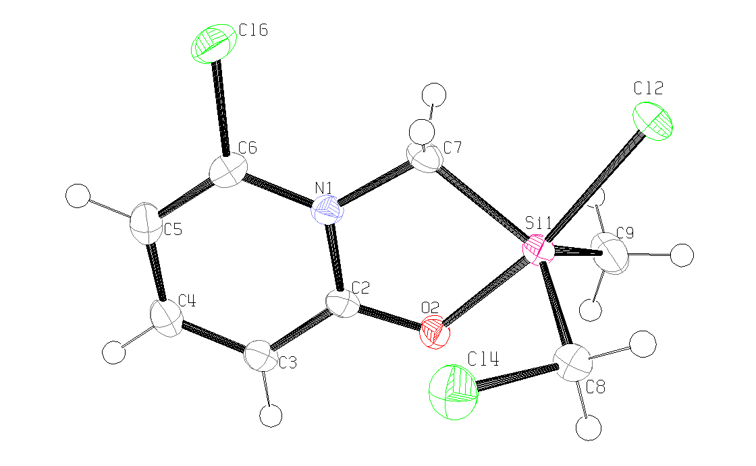
Table 1. Crystal data and structure refinement details.

Identification code 2008src0908 (SM 109Cl)
Empirical formula C₈H₁₀Cl₃NOSi
Formula weight 270.61
Temperature 120(2) K
Wavelength 0.71073 Å
Crystal system Monoclinic
Space group P21/n
Unit cell dimensions a = 8.7123(4) Å α = 90°
b = 14.4807(9) Å β = 105.322(3)°
c = 9.3751(5) Å γ = 90°
Volume 1140.72(11) Å³
Z 4
Density (calculated) 1.576 Mg / m³
Absorption coefficient 0.875 mm⁻¹
F(000) 552
Crystal block; colourless
Crystal size 0.36 × 0.20 × 0.09 mm³
θ range for data collection 3.61 − 27.48°
Index ranges −11 ≤ h ≤ 10, −18 ≤ k ≤ 18, −10 ≤ l ≤ 12
Reflections collected 13195
Independent reflections 2613 [R_{int} = 0.0661]
Completeness to θ = 27.48° 99.7 %
Absorption correction Semi−empirical from equivalents
Max. and min. transmission 0.9254 and 0.7436
Refinement method Full-matrix least-squares on F²
Data / restraints / parameters 2613 / 0 / 128
Goodness-of-fit on F² 1.058
Final R indices [F² > 2σ(F²)] R1 = 0.0430, wR2 = 0.1022
R indices (all data) R1 = 0.0686, wR2 = 0.1129
Largest diff. peak and hole 0.886 and −0.444 e Å⁻³

Diffractometer: Nonius KappaCCD area detector (φ scans and ω scans to fill asymmetric unit). Cell determination: DirAx (Duisenberg, A.J.M.(1992). J. Appl. Cryst. 25, 92-96.) Data collection: Collect (Collect: Data collection software, R. Hooft, Nonius B.V., 1998). Data reduction and cell refinement: Denzo (Z. Otwinowski & W. Minor, Methods in Enzymology (1997) Vol. 276: Macromolecular Crystallography, part A, pp. 307−326; C. W. Carter, Jr. & R. M. Sweet, Eds., Academic Press). Absorption correction: Sheldrick, G. M. SADABS - Bruker Nonius area detector scaling and absorption correction - V2.10 Structure solution: SHELXS97 (G. M. Sheldrick, Acta Cryst. (1990) A46 467−473). Structure refinement: SHELXL97 (G. M. Sheldrick (1997), University of Göttingen, Germany). Graphics: ORTEP-3 (L.G. Farrugia, J. Appl. Cryst. (1997) 30, 565).

Special details:
All hydrogens fixed using a standard riding model.
Table 2. Atomic coordinates [× 10⁴], equivalent isotropic displacement parameters [Å² × 10³] and site occupancy factors. U_{eq} is defined as one third of the trace of the orthogonalized U^{ij} tensor.

Atom x y z U_{eq} S.o.f.

C2 3283(3) 665(2) 5602(3) 19(1) 1
C3 3489(3) 755(2) 4177(3) 21(1) 1
C4 4699(3) 1294(2) 3969(3) 24(1) 1
C5 5732(3) 1763(2) 5151(3) 26(1) 1
C6 5495(3) 1661(2) 6521(3) 22(1) 1
C7 3950(3) 986(2) 8200(3) 22(1) 1
C8 95(3) 924(2) 7227(3) 25(1) 1
C9 1879(4) −979(2) 8119(3) 34(1) 1
N1 4296(2) 1123(2) 6757(2) 18(1) 1
O2 2197(2) 172(1) 5936(2) 22(1) 1
Si1 2038(1) 296(1) 7924(1) 20(1) 1
Cl2 2246(1) 570(1) 10378(1) 31(1) 1
Cl4 389(1) 2002(1) 6390(1) 35(1) 1
Cl6 6664(1) 2211(1) 8039(1) 31(1) 1
Table 3. Bond lengths [Å] and angles [°].

C2−O2 1.288(3)
C2−N1 1.373(3)
C2−C3 1.400(3)
C3−C4 1.367(4)
C3−H3 0.9500
C4−C5 1.404(4)
C4−H4 0.9500
C5−C6 1.362(4)
C5−H5 0.9500
C6−N1 1.368(3)
C6−Cl6 1.711(3)
C7−N1 1.475(3)
C7−Si1 1.902(3)
C7−H7A 0.9900
C7−H7B 0.9900
C8−Cl4 1.795(3)
C8−Si1 1.880(3)
C8−H8A 0.9900
C8−H8B 0.9900
C9−Si1 1.863(3)
C9−H9A 0.9800
C9−H9B 0.9800
C9−H9C 0.9800
O2−Si1 1.9137(18)
Si1−Cl2 2.2945(9)

O2−C2−N1 115.9(2)
O2−C2−C3 124.8(2)
N1−C2−C3 119.3(2)
C4−C3−C2 119.2(3)
C4−C3−H3 120.4
C2−C3−H3 120.4
C3−C4−C5 121.4(2)
C3−C4−H4 119.3
C5−C4−H4 119.3
C6−C5−C4 117.8(2)
C6−C5−H5 121.1
C4−C5−H5 121.1
C5−C6−N1 121.8(2)
C5−C6−Cl6 121.9(2)
N1−C6−Cl6 116.31(19)
N1−C7−Si1 109.24(17)
N1−C7−H7A 109.8
Si1−C7−H7A 109.8
N1−C7−H7B 109.8
Si1−C7−H7B 109.8
H7A−C7−H7B 108.3
Cl4−C8−Si1 110.71(14)
Cl4−C8−H8A 109.5
Si1−C8−H8A 109.5
Cl4−C8−H8B 109.5
Si1−C8−H8B 109.5
H8A−C8−H8B 108.1
Si1−C9−H9A 109.5
Si1−C9−H9B 109.5
H9A−C9−H9B 109.5
Si1−C9−H9C 109.5
H9A−C9−H9C 109.5
H9B−C9−H9C 109.5
C6−N1−C2 120.5(2)
C6−N1−C7 125.0(2)
C2−N1−C7 114.5(2)
C2−O2−Si1 115.60(16)
C9−Si1−C8 115.49(14)
C9−Si1−C7 126.35(14)
C8−Si1−C7 117.93(13)
C9−Si1−O2 91.71(11)
C8−Si1−O2 89.85(10)
C7−Si1−O2 83.97(10)
C9−Si1−Cl2 93.49(9)
C8−Si1−Cl2 95.15(9)
C7−Si1−Cl2 86.47(8)
O2−Si1−Cl2 170.42(7)

Symmetry transformations used to generate equivalent atoms:

Table 4. Anisotropic displacement parameters [Å²× 10³]. The anisotropic displacement
factor exponent takes the form: −2π ²[h²a*²U¹¹ + ... + 2 h k a* b* U¹² ].

Atom U¹¹ U²² U³³ U²³ U¹³ U¹²

C2 18(1) 20(1) 16(1) 1(1) 2(1) 3(1)
C3 21(1) 23(1) 18(1) 1(1) 4(1) 4(1)
C4 26(1) 25(2) 23(1) 6(1) 11(1) 6(1)
C5 26(1) 24(2) 30(2) 6(1) 12(1) 2(1)
C6 19(1) 21(1) 26(1) −4(1) 5(1) −1(1)
C7 24(1) 30(2) 13(1) −3(1) 4(1) −1(1)
C8 24(1) 30(2) 21(1) 0(1) 5(1) −1(1)
C9 46(2) 32(2) 24(2) 0(1) 11(1) −8(1)
N1 17(1) 21(1) 16(1) −1(1) 4(1) 0(1)
O2 24(1) 26(1) 17(1) −3(1) 7(1) −6(1)
Si1 21(1) 25(1) 15(1) −1(1) 4(1) −3(1)
Cl2 33(1) 45(1) 15(1) −4(1) 8(1) −5(1)
Cl4 37(1) 27(1) 41(1) 5(1) 14(1) 4(1)
Cl6 24(1) 37(1) 32(1) −10(1) 6(1) −10(1)

