Single Crystal X-Ray Diffraction Service

National Crystallography Service

Contact: Dr S.K. Callear, S.K.Callear@soton.ac.uk

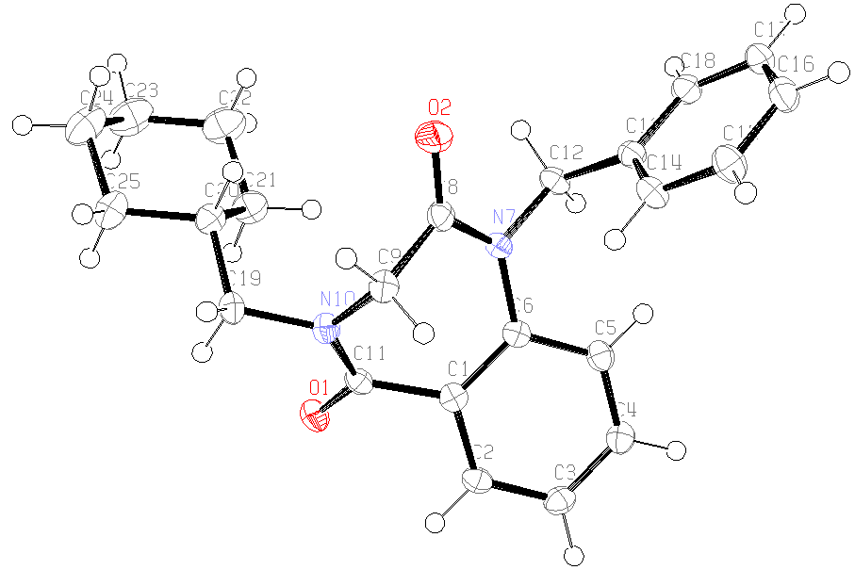
Table 1. Crystal data and structure refinement details.

Identification code 2008src0988 (JS Ganesh)
Empirical formula C₂₃H₂₆N₂O₂
Formula weight 362.46
Temperature 120(2) K
Wavelength 0.71073 Å
Crystal system Triclinic
Space group P−1
Unit cell dimensions a = 5.4658(2) Å α = 106.312(2)°
b = 12.1791(4) Å β = 99.182(2)°
c = 15.8842(5) Å γ = 102.509(2)°
Volume 962.93(6) Å³
Z 2
Density (calculated) 1.250 Mg / m³
Absorption coefficient 0.080 mm⁻¹
F(000) 388
Crystal rod; colourless
Crystal size 0.43 × 0.11 × 0.08 mm³
θ range for data collection 3.43 − 27.48°
Index ranges −7 ≤ h ≤ 7, −15 ≤ k ≤ 15, −19 ≤ l ≤ 20
Reflections collected 19642
Independent reflections 4394 [R_{int} = 0.0733]
Completeness to θ = 27.48° 99.8 %
Absorption correction Semi−empirical from equivalents
Max. and min. transmission 0.9936 and 0.9664
Refinement method Full-matrix least-squares on F²
Data / restraints / parameters 4394 / 0 / 245
Goodness-of-fit on F² 1.053
Final R indices [F² > 2σ(F²)] R1 = 0.0505, wR2 = 0.1130
R indices (all data) R1 = 0.0896, wR2 = 0.1299
Extinction coefficient 0.034(4)
Largest diff. peak and hole 0.222 and −0.262 e Å⁻³

Diffractometer: Nonius KappaCCD area detector (φ scans and ω scans to fill asymmetric unit ). Cell determination: DirAx (Duisenberg, A.J.M.(1992). J. Appl. Cryst. 25, 92-96.) Data collection: Collect (Collect: Data collection software, R. Hooft, Nonius B.V., 1998). Data reduction and cell refinement: Denzo (Z. Otwinowski & W. Minor, Methods in Enzymology (1997) Vol. 276: Macromolecular Crystallography, part A, pp. 307−326; C. W. Carter, Jr. & R. M. Sweet, Eds., Academic Press). Absorption correction: Sheldrick, G. M. SADABS - Bruker Nonius area detector scaling and absorption correction - V2.10 Structure solution: SHELXS97 (G. M. Sheldrick, Acta Cryst. (1990) A46 467−473). Structure refinement: SHELXL97 (G. M. Sheldrick (1997), University of Göttingen, Germany). Graphics: ORTEP-3 (L.G. Farrugia, J. Appl. Cryst. (1997) 30, 565).

Special details:
All hydrogens fixed using a standard riding model.
Table 2. Atomic coordinates [× 10⁴], equivalent isotropic displacement parameters [Å² × 10³] and site occupancy factors. U_{eq} is defined as one third of the trace of the orthogonalized U^{ij} tensor.

Atom x y z U_{eq} S.o.f.

C1 1507(3) −750(1) 1056(1) 19(1) 1
C2 2260(3) −816(2) 244(1) 21(1) 1
C3 2456(3) −1867(2) −323(1) 23(1) 1
C4 1929(3) −2881(2) −74(1) 23(1) 1
C5 1140(3) −2844(2) 717(1) 22(1) 1
C6 896(3) −1788(1) 1292(1) 18(1) 1
C8 −1508(3) −1200(1) 2465(1) 21(1) 1
C9 −2255(3) −342(2) 2013(1) 22(1) 1
C11 1791(3) 484(1) 1664(1) 19(1) 1
C12 664(3) −2715(2) 2504(1) 22(1) 1
C13 −1513(3) −3858(2) 2173(1) 20(1) 1
C14 −3726(3) −4043(2) 1523(1) 24(1) 1
C15 −5696(3) −5091(2) 1250(1) 28(1) 1
C16 −5520(3) −5972(2) 1628(1) 26(1) 1
C17 −3327(4) −5804(2) 2274(1) 27(1) 1
C18 −1331(3) −4766(2) 2538(1) 24(1) 1
C19 130(3) 1823(2) 2738(1) 23(1) 1
C20 963(3) 1969(2) 3737(1) 23(1) 1
C21 3472(4) 1642(2) 3972(1) 31(1) 1
C22 4294(4) 1863(2) 4988(1) 41(1) 1
C23 4575(4) 3148(2) 5534(1) 43(1) 1
C24 2102(4) 3500(2) 5302(1) 41(1) 1
C25 1245(4) 3259(2) 4289(1) 31(1) 1
N7 143(3) −1808(1) 2110(1) 19(1) 1
N10 −53(3) 646(1) 2119(1) 20(1) 1
O1 3671(2) 1303(1) 1724(1) 25(1) 1
O2 −2325(3) −1345(1) 3108(1) 33(1) 1
Table 3. Bond lengths [Å] and angles [°].

C1−C2 1.402(2)
C1−C6 1.404(2)
C1−C11 1.501(2)
C2−C3 1.380(2)
C2−H2 0.9500
C3−C4 1.387(2)
C3−H3 0.9500
C4−C5 1.384(2)
C4−H4 0.9500
C5−C6 1.400(2)
C5−H5 0.9500
C6−N7 1.430(2)
C8−O2 1.220(2)
C8−N7 1.377(2)
C8−C9 1.512(2)
C9−N10 1.456(2)
C9−H9A 0.9900
C9−H9B 0.9900
C11−O1 1.2376(19)
C11−N10 1.347(2)
C12−N7 1.470(2)
C12−C13 1.517(2)
C12−H12A 0.9900
C12−H12B 0.9900
C13−C14 1.391(2)
C13−C18 1.399(2)
C14−C15 1.386(2)
C14−H14 0.9500
C15−C16 1.381(2)
C15−H15 0.9500
C16−C17 1.384(3)
C16−H16 0.9500
C17−C18 1.387(2)
C17−H17 0.9500
C18−H18 0.9500
C19−N10 1.464(2)
C19−C20 1.528(2)
C19−H19A 0.9900
C19−H19B 0.9900
C20−C21 1.528(2)
C20−C25 1.530(2)
C20−H20 1.0000
C21−C22 1.533(2)
C21−H21A 0.9900
C21−H21B 0.9900
C22−C23 1.522(3)
C22−H22A 0.9900
C22−H22B 0.9900
C23−C24 1.526(3)
C23−H23A 0.9900
C23−H23B 0.9900
C24−C25 1.527(3)
C24−H24A 0.9900
C24−H24B 0.9900
C25−H25A 0.9900
C25−H25B 0.9900

C2−C1−C6 118.99(15)
C2−C1−C11 115.31(14)
C6−C1−C11 125.13(15)
C3−C2−C1 121.90(15)
C3−C2−H2 119.1
C1−C2−H2 119.1
C2−C3−C4 118.87(15)
C2−C3−H3 120.6
C4−C3−H3 120.6
C5−C4−C3 120.33(16)
C5−C4−H4 119.8
C3−C4−H4 119.8
C4−C5−C6 121.34(15)
C4−C5−H5 119.3
C6−C5−H5 119.3
C5−C6−C1 118.52(15)
C5−C6−N7 118.27(14)
C1−C6−N7 123.15(15)
O2−C8−N7 121.92(15)
O2−C8−C9 121.71(16)
N7−C8−C9 116.37(14)
N10−C9−C8 111.92(13)
N10−C9−H9A 109.2
C8−C9−H9A 109.2
N10−C9−H9B 109.2
C8−C9−H9B 109.2
H9A−C9−H9B 107.9
O1−C11−N10 122.98(15)
O1−C11−C1 119.37(15)
N10−C11−C1 117.64(14)
N7−C12−C13 113.69(13)
N7−C12−H12A 108.8
C13−C12−H12A 108.8
N7−C12−H12B 108.8
C13−C12−H12B 108.8
H12A−C12−H12B 107.7
C14−C13−C18 117.92(15)
C14−C13−C12 122.62(14)
C18−C13−C12 119.46(14)
C15−C14−C13 120.96(16)
C15−C14−H14 119.5
C13−C14−H14 119.5
C16−C15−C14 120.65(16)
C16−C15−H15 119.7
C14−C15−H15 119.7
C15−C16−C17 119.14(16)
C15−C16−H16 120.4
C17−C16−H16 120.4
C16−C17−C18 120.44(16)
C16−C17−H17 119.8
C18−C17−H17 119.8
C17−C18−C13 120.86(16)
C17−C18−H18 119.6
C13−C18−H18 119.6
N10−C19−C20 114.63(13)
N10−C19−H19A 108.6
C20−C19−H19A 108.6
N10−C19−H19B 108.6
C20−C19−H19B 108.6
H19A−C19−H19B 107.6
C19−C20−C21 113.12(15)
C19−C20−C25 108.33(14)
C21−C20−C25 110.27(14)
C19−C20−H20 108.3
C21−C20−H20 108.3
C25−C20−H20 108.3
C20−C21−C22 111.07(16)
C20−C21−H21A 109.4
C22−C21−H21A 109.4
C20−C21−H21B 109.4
C22−C21−H21B 109.4
H21A−C21−H21B 108.0
C23−C22−C21 111.44(17)
C23−C22−H22A 109.3
C21−C22−H22A 109.3
C23−C22−H22B 109.3
C21−C22−H22B 109.3
H22A−C22−H22B 108.0
C22−C23−C24 111.26(16)
C22−C23−H23A 109.4
C24−C23−H23A 109.4
C22−C23−H23B 109.4
C24−C23−H23B 109.4
H23A−C23−H23B 108.0
C23−C24−C25 111.31(17)
C23−C24−H24A 109.4
C25−C24−H24A 109.4
C23−C24−H24B 109.4
C25−C24−H24B 109.4
H24A−C24−H24B 108.0
C24−C25−C20 112.32(16)
C24−C25−H25A 109.1
C20−C25−H25A 109.1
C24−C25−H25B 109.1
C20−C25−H25B 109.1
H25A−C25−H25B 107.9
C8−N7−C6 124.13(13)
C8−N7−C12 115.60(13)
C6−N7−C12 118.90(14)
C11−N10−C9 120.92(14)
C11−N10−C19 120.52(14)
C9−N10−C19 118.55(14)

Symmetry transformations used to generate equivalent atoms:

Table 4. Anisotropic displacement parameters [Å²× 10³]. The anisotropic displacement
factor exponent takes the form: −2π ²[h²a*²U¹¹ + ... + 2 h k a* b* U¹² ].

Atom U¹¹ U²² U³³ U²³ U¹³ U¹²

C1 14(1) 21(1) 21(1) 7(1) 2(1) 5(1)
C2 18(1) 23(1) 22(1) 11(1) 5(1) 4(1)
C3 21(1) 28(1) 20(1) 7(1) 7(1) 5(1)
C4 21(1) 21(1) 26(1) 5(1) 7(1) 5(1)
C5 20(1) 20(1) 26(1) 7(1) 6(1) 5(1)
C6 14(1) 20(1) 20(1) 7(1) 3(1) 3(1)
C8 20(1) 17(1) 24(1) 5(1) 6(1) 1(1)
C9 18(1) 21(1) 24(1) 6(1) 6(1) 5(1)
C11 17(1) 20(1) 21(1) 10(1) 2(1) 5(1)
C12 21(1) 23(1) 24(1) 12(1) 4(1) 6(1)
C13 23(1) 21(1) 22(1) 9(1) 10(1) 9(1)
C14 24(1) 21(1) 30(1) 13(1) 7(1) 7(1)
C15 23(1) 25(1) 34(1) 12(1) 5(1) 5(1)
C16 26(1) 19(1) 35(1) 8(1) 13(1) 5(1)
C17 39(1) 19(1) 29(1) 11(1) 13(1) 10(1)
C18 29(1) 24(1) 22(1) 10(1) 6(1) 10(1)
C19 25(1) 17(1) 25(1) 6(1) 7(1) 8(1)
C20 23(1) 24(1) 23(1) 6(1) 6(1) 6(1)
C21 28(1) 35(1) 28(1) 10(1) 4(1) 9(1)
C22 37(1) 56(1) 29(1) 14(1) 2(1) 16(1)
C23 36(1) 56(2) 26(1) 5(1) 0(1) 5(1)
C24 39(1) 44(1) 28(1) −1(1) 7(1) 6(1)
C25 30(1) 30(1) 29(1) 2(1) 6(1) 8(1)
N7 19(1) 18(1) 20(1) 8(1) 6(1) 4(1)
N10 18(1) 19(1) 23(1) 6(1) 5(1) 6(1)
O1 23(1) 20(1) 31(1) 10(1) 7(1) 3(1)
O2 38(1) 33(1) 34(1) 14(1) 19(1) 11(1)

